
School of Digital, Technology, Innovation, and Business
Department of Engineering
MECH43025

ENGINEERING THERMOFLUIDS
FLUID PROPERTIES

Course: Engineering Thermofluids (MECH43025)
Module Leader: Dr Mohammad Ardekani
Student Name: Arpan K Roy
Deadline: 27/04/2026
Contents
Introduction 3
Methodology 4
Equipment 4
Procedure 4
Results 6
Exercise A - Density 6
Exercise B – Viscosity 8
Discussion 15
Conclusion 17
Key Findings 17
Recommendations for Improvement 17
References 18

List of Figures
Figure 1. Difference in viscosity of oil and water 3
Figure 2. Test Fluids placed inside the measuring cylinders 5
Figure 3. Hydrometer floating in a measuring cylinder containing golden syrup for specific gravity measurement. 6
Figure 4. A falling sphere viscometer setup is used to measure fluid viscosity. 8
Figure 5. Steel spheres of various diameters and a digital stopwatch were used for timing measurements. 9

List of Tables
Table 1. Results for Specific Gravity 6
Table 2. Results for the density of the liquids 7
Table 3. Results for Dynamic and Kinematic Viscosity 8
Table 4. Mean velocity, Dynamic Viscosity, and Kinematic Viscosity of spheres falling in different fluids 14

Introduction
Fluid mechanics is a fundamental branch of engineering that studies the behaviour of liquids and gases at rest and in motion. Fluid mechanics studies the behaviour of fluids by analysing properties such as density, viscosity, pressure, and velocity, which determine how fluids respond to these forces and flow conditions (Fluid Mechanics: Çengel and Cimbala (2018), pg.2). Density and Viscosity are the two key physical properties that describe fluid behaviour.
Density is defined as mass per unit volume, and it is an important factor in determining buoyancy, pressure distribution, and fluid stratification. It plays a critical role in engineering applications such as hydraulic systems, fuel storage, and process industries, where fluid composition and behaviour must be precisely controlled.
$$ρ=\frac{m}{v}$$
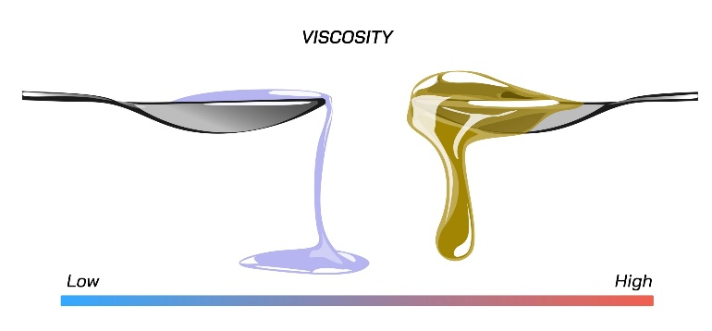
Viscosity describes a fluid's resistance to deformation or flow under shear or stress. It defines the internal friction between layers of fluids moving at different velocities. Fluids having high viscosity, such as oils, resist motion more strongly than low viscosity fluids like water, as shown in Figure 1. Viscosity may be dynamic, which measures resistance to shear, or kinematic, which relates dynamic viscosity to fluid density. Precise knowledge of viscosity is essential in many engineering fields, including lubrication design, pipeline transport, aerodynamic performance, and thermal systems.
Figure 1. Difference in viscosity of oil and water
The motion of small particles through a fluid can be used to study how fluids resist flow. Under laminar flow conditions, the drag force acting on a sphere moving through a viscous fluid can be described using Stokes’ Law, which relates the viscous force to fluid velocity, particle size, and velocity. When a falling sphere reaches its maximum velocity, the balance between gravitational, buoyant, and viscous forces allows viscosity to be determined experimentally.
The study aims to measure the density and viscosity of a selection of fluids and to evaluate their flow characteristics using principles of fluid mechanics. The investigation seeks to determine the dynamic and kinematic viscosities, compare the results across different fluids, and assess how the experimental values align with theoretical expectations.

Methodology

Equipment
The experiment was done using a few laboratories equipment to measure the density and viscosity of the selected fluids. The primary instrument used to measure density was a hydrometer, which determines the specific gravity of a liquid based on the depth to which it floats. A falling ball viscometer was used to measure the viscosity of the fluids by observing the motion of spheres travelling through the liquid. Other equipment used during the experiment is as follows:
- Steel sphere balls of different diameters
- Stopwatch
- Ruler or measurement scale on the viscometer
- Thermometer for temperature measurement
- Measuring cylinders
- Multiple test fluids used in the experiment (Water, Washing Liquid, Olive Oil, & Golden Syrup)
- Smartphone to record in slow-motion
Specific gravity, velocity, and time were used to calculate the density and viscosity later.

Procedure
Measurement of Density
The density of each fluid was measured using a hydrometer. The test fluid was first poured into a transparent measuring cylinder to a certain depth to allow the hydrometer to float freely. The hydrometer was then carefully placed into the fluid and left to stabilise without touching the sides of the container. Once the hydrometer reached its equilibrium point, the specific gravity reading was noted from the calibrated scale at the fluid surface level. The same procedure was then repeated for all the fluids. The density of the fluid was then determined by relating the specific gravity value to the density of water (1000 kg/m³)
$$SPECIFIC GRAVITY= \frac{ρ}{ρ_{H20}}$$
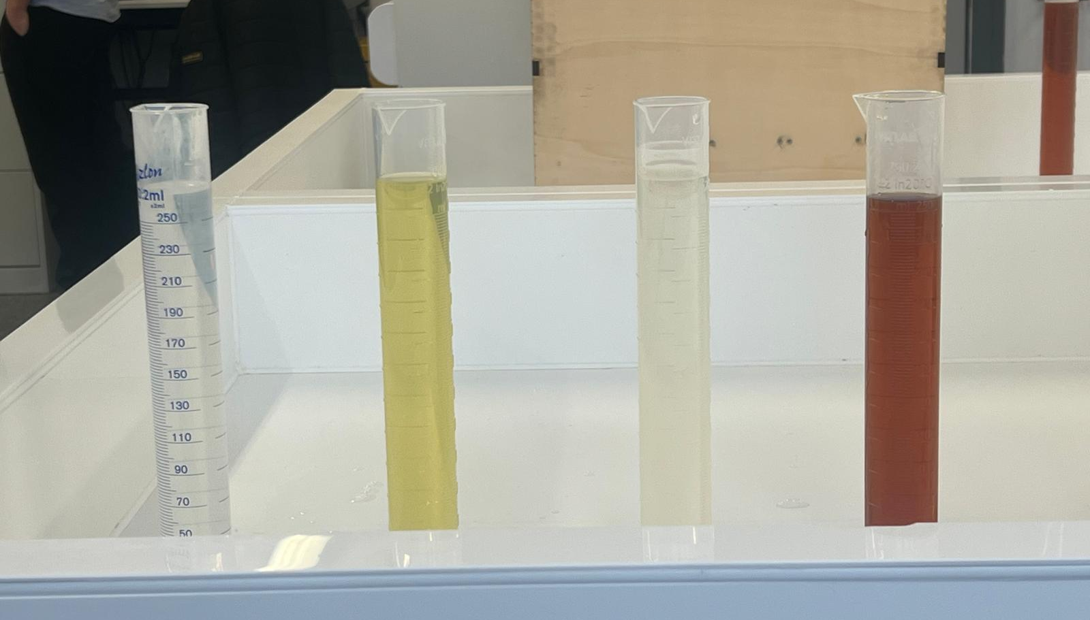
Figure 2. Test fluids are placed inside the measuring cylinders
Measurement of Viscosity
The viscosity of the fluids was determined using a falling ball viscometer. The viscometer tube was filled with the selected fluid and positioned vertically. Steel spheres of known diameter were released individually from the top. As the sphere travelled through the fluid, the time taken to move between two marked points on the viscometer was recorded using a stopwatch. Multiple measurements were taken for each sphere to improve accuracy. The velocity of the falling sphere was calculated using the measured distance between points and the recorded time.
$$v=\frac{d}{t}$$
Once the sphere reached its terminal velocity, the forces acting on the sphere were in equilibrium. Using the measured velocity and the known radius of the sphere, the dynamic viscosity of the fluid was calculated using Stokes’ Law:
$$F_{v}=6πμrv$$
where, $F_{v}$ - viscous force
$μ$ - dynamic viscosity of fluid
$r$ - radius of sphere
$v$ - velocity of sphere
The procedure was repeated for the different sphere sizes and with the different fluids to obtain a range of viscosity values for comparison.

Results

Exercise A - Density
- Specific Gravity
Barometric pressure: 991.2 hPa
Temperature: 18 °C
Table 1. Results for Specific Gravity
Liquid | Scale Reading = Specific Gravity, s
Water | 1
washing liquid | 1.04
Olive oil | 0.82
Golden Syrup | 1.53

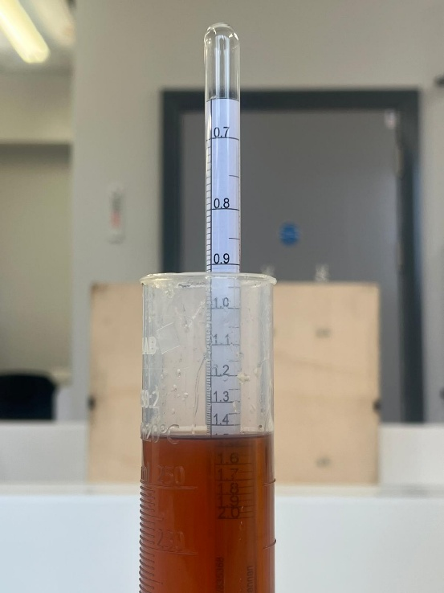
Figure 3. Hydrometer floating in a measuring cylinder containing golden syrup for specific gravity measurement.
- Density of the Liquid
$$ρ_{liquid}=SG x ρ_{water}$$
Table 2. Results for the density of the liquids
Liquid | Density r, kg/m³
Water | 1000
washing liquid | 1040
Olive oil | 820
Golden Syrup | 1530

Fluid Density Calculation:
Water:
$ρ_{water}=$1 x 1000 = 1000 $kg/m^{3}$
Washing Liquid:
$ρ_{washing liquid}=$1.04 x 1000 = 1040 $kg/m^{3}$
Olive Oil:
$ρ_{olive oil}=$0.82 x 1000 = 820 $kg/m^{3}$
Golden Syrup:
$ρ_{golden syrup}=$1.53 x 1000 = 1530 $kg/m^{3}$

Exercise B – Viscosity
Barometric pressure: 991.2 hPa
Temperature: 18 °C
Specific gravity of steel ball: 7.8
Table 3. Results for Dynamic and Kinematic Viscosity
 | Time to fall marked distance / s
 | Golden Syrup |  | Washing liquid |  | Olive oil
Ball bearing Diameter (mm) | 200-175 mm | 175-100 mm | 100-25 mm | 25-0 mm | 100-25 mm | 25-0 mm
1.59 | N/A | N/A | 56.26 | 19.26 | 0.78 | 0.24
2.38 | 79.68 | 268.45 | 25.21 | 8.11 | 0.43 | 0.14
3.175 | 30.41 | 148.17 | 13.68 | 4.57 | 0.29 | 0.11
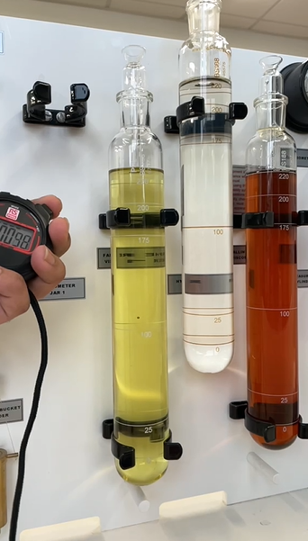
Figure 4. A falling sphere viscometer setup is used to measure fluid viscosity.
Sphere Radius Calculations
1.59 mm sphere ball
$$r=\frac{1.59}{2}=0.795 mm=7.95×{10}^{-4} m$$
2.38 mm sphere ball
$$r=\frac{2.38}{2}=1.19 mm=1.19×{10}^{-3} m$$
3.175 mm sphere ball
$$r=\frac{3.175}{2}=1.58 mm=1.58×{10}^{-3} m$$
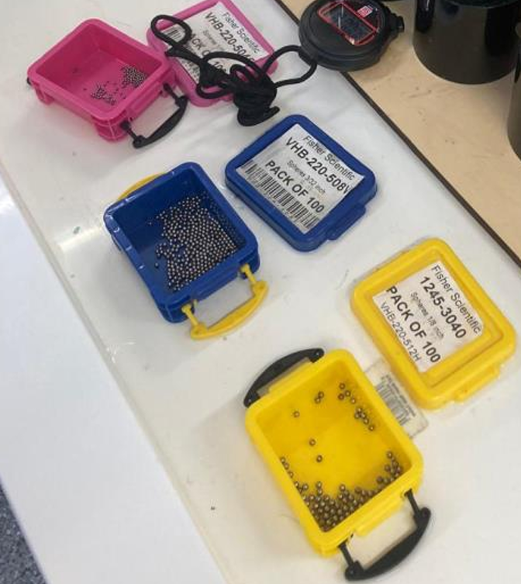
Figure 5. Steel spheres of various diameters and a digital stopwatch were used for timing measurements.
Distance conversions
Golden Syrup
$200-175=25 mm$ = $25×{10}^{-3} m$
$175-100=75 mm$ = $75×{10}^{-3} m$

Washing liquid and Olive Oil

$100-25=75 mm$ = $75×{10}^{-3} m$
$25-0=25 mm$ = $25×{10}^{-3} m$
Velocity calculations
$$u=\frac{Distance through which the ball falls}{Time}$$
Mean velocity
$$u=\frac{u_{1}+ u_{2}}{2}$$
Dynamic viscosity
$$μ= \frac{4πr^{3}g}{3×6πru} \left(ρ_{s}-ρ_{1}\right)= \frac{2}{9} r^{2}g\frac{\left(ρ_{s}-ρ_{1}\right)}{u}$$
Kinematic viscosity
$$ν=\frac{μ}{ρ}$$
Golden Syrup
- 1.59
No results were obtained due to the time it would have taken for the experiment, and viscosity could not be calculated for these conditions.
- 2.38
$$u_{1}=\frac{25×{10}^{-3} }{79.68}=3.14×{10}^{-4} m/s$$
$$u_{2}=\frac{75×{10}^{-3} }{268.45}=2.79×{10}^{-4} m/s$$
Mean velocity,
$$u=\frac{u_{1}+ u_{2}}{2}= \frac{3.14×{10}^{-4}+2.79×{10}^{-4} }{2}=2.97×{10}^{-4} m/s$$
Dynamic Viscosity,
$$μ= \frac{2}{9} r^{2}g\frac{\left(ρ_{s}-ρ_{1}\right)}{u}=\frac{2}{9} {\left(1.19×{10}^{-3}\right)}^{2}\left(9.81\right)\frac{\left(7800-1530\right)}{2.97×{10}^{-4} }=65.1 Pa∙s$$
Kinematic Viscosity,
$$ν=\frac{μ}{ρ}=\frac{65.1}{1530}=4.25×{10}^{-2 } m^{2}/s$$
- 3.175
$$u_{1}=\frac{25×{10}^{-3} }{30.41}=8.22×{10}^{-4} m/s$$
$$u_{2}=\frac{75×{10}^{-3} }{148.17}=5.06×{10}^{-4} m/s$$
Mean velocity,
$$u= \frac{u_{1}+ u_{2}}{2}= \frac{8.22×{10}^{-4}+5.06×{10}^{-4} }{2}=6.64×{10}^{-4} m/s$$
Dynamic Viscosity,
$$μ= \frac{2}{9} r^{2}g\frac{\left(ρ_{s}-ρ_{1}\right)}{u}=\frac{2}{9} {\left(1.58×{10}^{-3}\right)}^{2}\left(9.81\right)\frac{\left(7800-1530\right)}{6.64×{10}^{-4} }=51.39 Pa∙s$$
Kinematic Viscosity,
$$ν=\frac{μ}{ρ}=\frac{51.39}{1530}=3.36×{10}^{-2 } m^{2}/s$$
Washing Liquid
- 1.59
$$u_{1}=\frac{75×{10}^{-3} }{56.26}=1.33×{10}^{-3} m/s$$
$$u_{2}=\frac{25×{10}^{-3} }{19.26}=1.3×{10}^{-3} m/s$$
Mean velocity,
$$u=\frac{u_{1}+ u_{2}}{2}= \frac{1.33×{10}^{-3}+ 1.3×{10}^{-3}}{2}=1.32×{10}^{-3} m/s$$
Dynamic Viscosity,
$$μ= \frac{2}{9} r^{2}g\frac{\left(ρ_{s}-ρ_{1}\right)}{u}=\frac{2}{9} {\left(7.95×{10}^{-4}\right)}^{2}\left(9.81\right)\frac{\left(7800-1040\right)}{1.32×{10}^{-3} }=7.1 Pa∙s$$
Kinematic Viscosity,
$$ν=\frac{μ}{ρ}=\frac{7.1}{1040}=6.83×{10}^{-3} m^{2}/s$$
- 2.38
$$u_{1}=\frac{75×{10}^{-3} }{25.21}=2.97×{10}^{-3} m/s$$
$$u_{2}=\frac{25×{10}^{-3} }{8.11}=3.08×{10}^{-3} m/s$$
Mean velocity,
$$u= \frac{u_{1}+ u_{2}}{2}= \frac{2.97×{10}^{-3}+ 3.08×{10}^{-3} }{2}=3.03×{10}^{-3} m/s$$
Dynamic Viscosity,
$$μ= \frac{2}{9} r^{2}g\frac{\left(ρ_{s}-ρ_{1}\right)}{u}=\frac{2}{9} {\left(1.19×{10}^{-3}\right)}^{2}\left(9.81\right)\frac{\left(7800-1040\right)}{3.03×{10}^{-3} }=6.89 Pa∙s$$
Kinematic Viscosity,
$$ν=\frac{μ}{ρ}=\frac{6.89}{1040}=6.62×{10}^{-3} m^{2}/s$$
- 3.175
$$u_{1}=\frac{75×{10}^{-3} }{13.68}=5.48×{10}^{-3} m/s$$
$$u_{2}=\frac{25×{10}^{-3} }{4.57}=5.47×{10}^{-3} m/s$$
Mean velocity,
$$u=\frac{u_{1}+ u_{2}}{2}= \frac{5.48×{10}^{-3}+ 5.47×{10}^{-3}}{2}=5.48×{10}^{-3} m/s$$
Dynamic Viscosity,
$$μ= \frac{2}{9} r^{2}g\frac{\left(ρ_{s}-ρ_{1}\right)}{u}=\frac{2}{9} {\left(1.58×{10}^{-3}\right)}^{2}\left(9.81\right)\frac{\left(7800-1040\right)}{5.48×{10}^{-3} }=6.71 Pa∙s$$
Kinematic Viscosity,
$$ν=\frac{μ}{ρ}=\frac{6.71}{1040}=6.45×{10}^{-3} m^{2}/s$$
Olive Oil
- 1.59
$$u_{1}=\frac{75×{10}^{-3} }{0.78}=9.62×{10}^{-2} m/s$$
$$u_{2}=\frac{25×{10}^{-3} }{0.24}=1.04×{10}^{-1} m/s$$
Mean velocity,
$$u= \frac{u_{1}+ u_{2}}{2}= \frac{9.62×{10}^{-2}+ 1.04×{10}^{-1} }{2}=1×{10}^{-1} m/s$$
Dynamic Viscosity,
$$μ= \frac{2}{9} r^{2}g\frac{\left(ρ_{s}-ρ_{1}\right)}{u}=\frac{2}{9} {\left(7.95×{10}^{-4}\right)}^{2}\left(9.81\right)\frac{\left(7800-820\right)}{1×{10}^{-1} }=0.096 Pa∙s$$
Kinematic Viscosity,
$$ν=\frac{μ}{ρ}=\frac{0.096}{820}=1.17×{10}^{-4} m^{2}/s$$
- 2.38
$$u_{1}=\frac{75×{10}^{-3} }{0.43}=1.74×{10}^{-1} m/s$$
$$u_{2}=\frac{25×{10}^{-3} }{0.14}=1.79×{10}^{-1} m/s$$
Mean velocity,
$$u= \frac{u_{1}+ u_{2}}{2}= \frac{1.74×{10}^{-1}+1.79×{10}^{-1} }{2}=1.77×{10}^{-1} m/s$$
Dynamic Viscosity,
$$μ= \frac{2}{9} r^{2}g\frac{\left(ρ_{s}-ρ_{1}\right)}{u}=\frac{2}{9} {\left(1.19×{10}^{-3}\right)}^{2}\left(9.81\right)\frac{\left(7800-820\right)}{1.77×{10}^{-1} }=0.122 Pa∙s$$
Kinematic Viscosity,
$$ν=\frac{μ}{ρ}=\frac{0.122}{820}=1.49×{10}^{-4} m^{2}/s$$
- 3.175
$$u_{1}=\frac{75×{10}^{-3} }{0.29}=2.59×{10}^{-1} m/s$$
$$u_{2}=\frac{25×{10}^{-3} }{0.11}=2.27×{10}^{-1} m/s$$
Mean velocity,
$$u=\frac{u_{1}+ u_{2}}{2}= \frac{2.59×{10}^{-1}+2.27×{10}^{-1} }{2}=2.43×{10}^{-1} m/s$$
Dynamic Viscosity,
$$μ= \frac{2}{9} r^{2}g\frac{\left(ρ_{s}-ρ_{1}\right)}{u}=\frac{2}{9} {\left(1.58×{10}^{-3}\right)}^{2}\left(9.81\right)\frac{\left(7800-820\right)}{2.43×{10}^{-1} }=0.156 Pa∙s$$
Kinematic Viscosity,
$$ν=\frac{μ}{ρ}=\frac{0.156}{820}=1.9×{10}^{-4} m^{2}/s$$
Table 4. Mean velocity, Dynamic Viscosity, and Kinematic Viscosity of spheres falling in different fluids
Fluid | Sphere Diameter (mm) | Mean Velocity ($m/s$) | Dynamic Viscosity  ($Pa∙s)$ | Kinematic Viscosity  ($m^{2}/s$)
Golden Syrup | 2.38 | $$2.97×{10}^{-4}$$ | 65.1 | $$4.25×{10}^{-2}$$
Golden Syrup | 3.175 | $$6.64×{10}^{-4}$$ | 51.39 | $$3.36×{10}^{-2}$$
Washing Liquid | 1.59 | $$1.32×{10}^{-3}$$ | 7.1 | $$6.83×{10}^{-3}$$
Washing Liquid | 2.38 | $$3.03×{10}^{-3}$$ | 6.89 | $$6.62×{10}^{-3}$$
Washing Liquid | 3.175 | $$5.48×{10}^{-3}$$ | 6.71 | $$6.45×{10}^{-3}$$
Olive Oil | 1.59 | $$1×{10}^{-1}$$ | 0.096 | $$1.17×{10}^{-4}$$
Olive Oil | 2.38 | $$1.77×{10}^{-1}$$ | 0.122 | $$1.49×{10}^{-4}$$
Olive Oil | 3.175 | $$2.43×{10}^{-1}$$ | 0.156 | $$1.9×{10}^{-4}$$
The results show a clear relationship between velocity & viscosity, where fluids with lower velocities show higher viscosity. The consistency of values across different sphere diameters suggests that the experimental results are reliable.

Discussion
The result from the experiment demonstrates a clear relationship between fluid velocity and viscosity, where fluids with lower mean velocities exhibit significantly higher velocities. This behaviour is consistent with Stokes’ Law, which states that the terminal velocity of a sphere moving through a viscous fluid is inversely proportional to the fluid’s viscosity. As a result, highly viscous fluids such as golden syrup produced very low velocities and high viscosity values, whereas low-viscosity fluids such as olive oil allowed the spheres to fall much faster.
The magnitude of the viscosity values obtained for each fluid also aligns with expected physical behaviour. Golden syrup has the highest dynamic viscosity values of approximately 72.5 Pa·s, which reflects its strong internal resistance to flow. Washing liquid showed values of around 7 Pa·s, while olive oil exhibited the lowest viscosities of approximately 0.096–0.113 Pa·s. According to Fluid Mechanics: Fundamentals and Applications, viscosity is a measure of internal friction between fluid layers, meaning fluids with stronger intermolecular forces will resist motion more and therefore have higher viscosity (Fluid Mechanics: Çengel and Cimbala (2018)). This explains why golden syrup, which is thicker and more cohesive, produces much higher values compared to olive oil.
When compared with published data, the results show good agreement in terms of overall trends, although some differences in magnitude are observed. Literature values indicate that olive oil typically has a dynamic viscosity in the range of approximately 0.05–0.1 Pa·s at room temperature (Lin, 2025), which is close to the experimental values obtained in this study. This suggests that the experimental method produced reasonably accurate results for lower viscosity fluids. However, for higher viscosity fluids such as golden syrup, the measured values appear relatively large. This discrepancy can be explained by the strong dependence of viscosity on temperature. As reported by Temperature-dependence of olive oil viscosity, viscosity decreases significantly with increasing temperature. Since the experiment was conducted at 18°C, which is slightly lower than standard laboratory conditions, the fluids would have been more viscous, leading to higher measured values.
The consistency of results across different sphere diameters further supports the reliability of the experiment. For each fluid, the calculated viscosity values remain relatively stable despite changes in sphere size, indicating that the assumption of terminal velocity was reasonably satisfied. This suggests that the flow conditions were predominantly laminar and that Stokes’ Law was applicable in most cases. However, slight variations in olive oil results may indicate that the flow was approaching transitional conditions at higher velocities, which can reduce the accuracy of the model.
Despite the overall agreement with theoretical expectations, several experimental factors may have influenced the results. One significant source of uncertainty is the assumption that the spheres reached terminal velocity within the measured distance. If the sphere had not fully stabilised before entering the timing region, the velocity recorded would be higher than the true terminal velocity, resulting in an underestimation of viscosity. Additionally, the use of a manual stopwatch introduces human reaction time error, particularly for low-viscosity fluids where the sphere travels quickly, though the use of slow-motion capture enables minimal error. The alignment of the viscometer tube is another critical factor; any slight deviation from vertical could cause the sphere to interact with the tube walls, increasing resistance and affecting the measured velocity.
Furthermore, small inaccuracies in measuring the sphere diameter can significantly impact the calculated viscosity, as the radius is squared in the equation. Temperature variations during the experiment may also have contributed to inconsistencies, as even minor changes can alter the viscosity of a fluid. These factors collectively explain the minor discrepancies between experimental and reference values while still supporting the overall validity of the results.
In conclusion, the experiment successfully demonstrates the relationship between viscosity, velocity, and fluid properties, with results that are consistent with theoretical predictions and supported by published data. While some deviations exist due to experimental limitations, the trends observed confirm the applicability of Stokes’ Law and highlight the importance of controlling experimental conditions when measuring fluid properties.

Conclusion
This experiment aimed to measure the density and viscosity of a selection of fluids and to evaluate their flow behaviour using principles of fluid mechanics. This included determining both dynamic and kinematic viscosities using a falling-sphere method and comparing the results across different fluids. Overall, the objectives of the experiment were successfully met, as consistent trends were observed and the calculated values showed reasonable agreement with theoretical expectations and published data.

Key Findings
- Fluids with higher viscosity exhibited lower velocities, confirming the inverse relationship predicted by Stokes’ Law.
- Golden syrup showed the highest viscosity, indicating strong internal resistance to flow.
- Washing liquid displayed moderate viscosity, behaving as an intermediate fluid.
- Olive oil had the lowest viscosity, allowing the spheres to reach higher velocities.
- The consistency of viscosity values across different sphere sizes suggests that terminal velocity conditions were reasonably achieved.
- Minor deviations in results were mainly due to temperature effects and experimental limitations.

Recommendations for Improvement
- Use electronic timing systems or sensors instead of a manual stopwatch to reduce human reaction time errors.
- Maintain a constant and controlled temperature throughout the experiment, as viscosity is highly temperature dependent.
- Use a more precise measurement method for sphere diameter to reduce calculation errors.
- Ensure the apparatus is perfectly vertical to prevent the sphere from touching the walls and affecting motion.
- Repeat each measurement multiple times and calculate an average over multiple trials to improve reliability.

References
- Fluid Mechanics: Fundamentals and Applications - Çengel & Cimbala
Available at:
https://lunyax.wordpress.com/wp-content/uploads/2018/04/fluid-mechanics-fundaments-and-applications.pdf
[Accessed on 12 March 2026]
- Nierat T.H., Musameh S.M., and Ashqer I. (2014) - Temperature-dependence of olive oil viscosity. Materials Science.
Available at:
https://www.researchgate.net/publication/263012034_Temperature-dependence_of_olive_oil_viscosity
[Accessed on 2 April 2026]
- Lin, A. (2025) - Reference Guide for Evaluating Liquid Material Viscosity.
Available at:
https://www.siliconeab.com/solutions/liquid-material-viscosity.html
[Accessed on 16 April 2026]

